Diffusion Limited Cluster-Cluster Aggregation : toward a unified and reference algorithm?

J. Yon, F.-X. Ouf, F. Corbin

Introduction

Fractal aggregates are encountered in many aggregation processes during nanomaterial production or combustion process. An aggregate is constituted of N_{p} primary spheres whose i^{st} radius is written R_{pi}. Thanks to the observations by Transmission Electron Microscope (TEM) or by analyzing the angular light scattering by these particles, it has been clearly demonstrated that number of primary spheres in an aggregates is in power law with aggregate size (equ. 1).
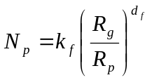 | equ. 1
In this equation called fractal law, R_{g} is called gyration radius and represents a purely geometrical size parameter (see equ. 2). In this equation, L_{i} is the distance between the aggregate centre of mass and the centre of the i^{st} primary sphere, considering here primary spheres of varying radii.
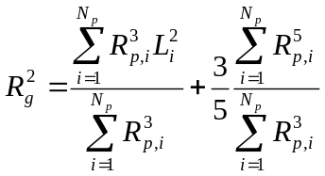 | equ. 2
In equ. 1, d_{f} and k_{f} corresponds respectively to the fractal dimension and prefactor. These parameters are directly linked to the morphology of the “fractal” aggregates. The determination of d_{f} and k_{f} for such particles is essential for understanding their physical behaviour (emissions, transport, coagulation, toxicological and environmental impact…). Indeed, realistic virtual generation of aggregates particles is essential for the evaluation of filtration efficiency, determination of nano-aggregates optical properties, kinetic of soot particle generation in flames, hydrodynamique properties… The fractal structure of aggregates is mainly dominated by the thermal Brownian motion of nano or submicronic particles. When particle mean free path λ_{p} in the surrounding gas is higher than distance between particles (d_{i}), aggregation is ballistic (BLA). On the contrary when λ_{p}< d_{i} aggregation is driven by diffusion motion (DLA : Diffusion Limited Aggregation). The two approaches are encountered to simulate aggregation. DLA or BLA codes are used to generate one aggregate of interest which is surrounded by primary spheres in thermal motion. More sophistically, aggregation of many clusters in the same volume of interest is called DLCA or BCA for Cluster aggregation. The use of DLCA or BLCA codes to simulate soot particles or colloids has been comforted by the fact that such generated aggregates respect the fractal law (equ. 1) with corresponding fractal dimension and prefactor similar to that ones determined experimentally (d_{f}≈1.8-2, k_{f}≈1-2 ).
DLCA codes have common simple algorithms. At each iteration, a particle is arbitrary selected. The diffusion coefficient of the selected particle is evaluated using simplified approach D=D₀m^{γ} where D₀ is a constant, m the particle mass and γ a constant used to take into account the fractal nature of aggregates.
Particles is displaced if D/D_{max}>X where D_{max} is the highest encountered diffusion parameter in the simulation and 0<X<1 an arbitrary fixed parameter. With that test, smallest particles (characterized by highest diffusion coefficients) are most often displaced than bigger ones taking into account their more intense Brownian motion. The particle displacement is generally considered constant and equal to the primary sphere diameter. That displacement can be 1D, 2D or 3D along an arbitrary orientation or in latticed configuration. In DLCA codes, when a contact occurs, aggregation is systematically associated. To simulate less intense attractive forces, aggregation can be considered after a certain number of contact (Raction Limited Aggregation), see Meakin for more information. In fact DLCA/RLCA or BLCA simple tools allowing the generation of realistic aggregates. Nevertheless these tools are limited by different aspects:
- Particle displacement is arbitrary fixed. That limitation does not permit to simulate a possible continuous transition between ballistic and diffusion aggregation BA-DLA that is suspected to occur as a function of particle concentration during aggregation process.
- The taking into account of aggregate morphology for determining diffusion coefficient is limited to γ parameter in Error: Reference source not found. But how to choose this parameter? This expression of diffusion coefficient does not allow a taking into account of flow regime transition from molecular flow to continuum flow during particle growth.
- Physical parameters as temperature T, pression P, gas nature, primary particle size are not explicitly taken into account.
- That modelisation of agglomeration process does not permit to evaluate a physical residence time.

In order to answer to these questions Hayashi et al. (1999) proposed a DLCA code that attribute to each particle a displacement equal to its physically calculated mean free path (λ_{p}) explicitly taking into account of T, P. But, particles are randomly selected and displaced without taking into account that during this displacement, other particles of different sizes don’t move at the same velocity and thus can run numerous mean free path and thus should be selected more often. In consequence, time progression is different for each particle leading to a not physical global residence time.

The aim of the present paper is to propose a new aggregation algorithm able to evaluate aggregate diffusion coefficient as a function of it gyration radius and thermodynamic conditions. This permits to take into account a possible change of flow regime during clusters aggregation. As proposed by Hayashi et al. (1999) particles are displaced along their mean free path allowing a physically driven transition between BLCA to DLCA. In opposition to Hayashi et al., particles will be selected with a physically based ponderation law different that one classically used in DLCA, allowing the determination of a more realistic residence time. So, in the present paper, a new algorithm is presented. Impact of volume fraction, primary particle size and temperature on aggregation kinetic, size distributions, particle morphology and residence time will be studied. Additionally to these algorithm enhancements, the second purpose of the present work is to propose a reference code for studied based on virtually conceived fractal aggregates. It is the reason why present code written in C++ can be freely download on the www.coria.fr website. That work has been performed within the framework of a study concerned by aeronautic emissions driven by the “Direction Generale de L'Aviation Civile” which is a part of the French Ministry of Transport.

DLCA algorithm

Basis
First, N primary spheres are randomly positioned in a virtual cubic domain of size L.
The distribution of the primary spheres’ diameter can be normal (equ. 3) or log-normal (equ. 4) where D_{pm} and D_{geo} are the modal diameters of the distributions and σ and σ_{geo} respectively the standard deviation and geometric standard deviation of the distribution :
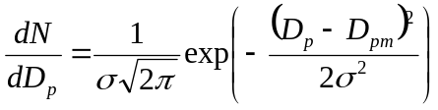 | equ. 3

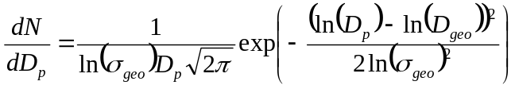 | equ. 4
In order to compare aggregation with same aggregates volume fraction, the box width L is determined by the following equation respectively in case of normal or lognormal primary sphere size distributions (equ. 5):
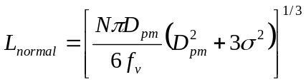 or 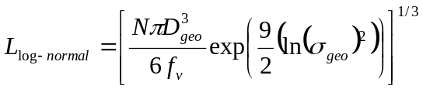 | equ. 5
Each primary sphere is labelized to simulate its affiliation to a given aggregate. Initially, before the beginning of aggregation, there are as many primary spheres as aggregates.
At time t, one of the N_{agg} clusters in the domain is selected respecting a law that will be explained later. A randomly normalized vector is determined indicating the direction and the way of the particle displacement. Then, particle is displaced along the mean free path λ_{p} determined with equ. 6 where k_{B}=1,38.10⁻²³ N.m/K is the Boltzmann constant, T (K) is the surrounding gaz temperature, C_{c} the Cunningham slip factor, η the gaz viscosity, D_{m} the mobility diameter of the particle and the aggregate speed.
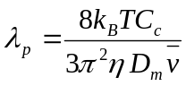 | equ. 6
The Cunningham slip factor is expressed in equ. 7 with A=1.142, B=0.558 and C=0.999. That factor is used to take into account a possible change of flow regime (K_{n}) during the particle growth (equ. 8).
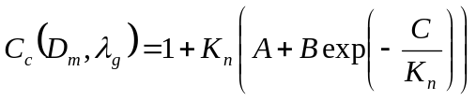 with 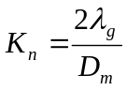 | equ. 7
In equ. 8, λ_{g} is the mean free path of the surrounding gaz at pressure P (Pa) and temperature T. It can be determined knowing the mean free path of the surrounding gaz λ_{g,ref} at a reference pressure and temperature (P_{r} = 101.3 kPa and T_{r}=293.15 K) with the Sutterland constant S=110 K.
with 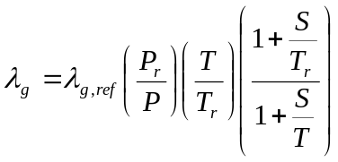 | equ. 8
The viscosity of the gaz used in equ. 6 can be determined with equ. 9 where η_{ref} is the gaz viscosity at a reference temperature.
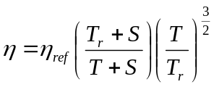 | equ. 9
The aggregate velocity used in equ. 6 is evaluated by using equ. 10 with m_{a} the aggregate mass and ρ_{p} the material density.
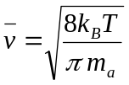 with 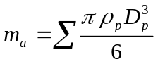 | equ. 10
If the particle displacement provokes a collision, a new aggregate is obtained. The new aggregate is analysed in terms of mass m_{a} (equ. 10) and gyration radius R_{g} (equ. 2). The corresponding mobility diameter D_{m} has to be determined for calculation of the new mean free path λ_{p} (equ. 6) and velocity (equ. 10). The determination of a fractal aggregate mobility diameter is not easy. Indeed, contrarily to the gyration radius which is a purely geometrical parameter, mobility diameter also depends of thermodynamical parameters (P, T, surrounding gaz, flow regime…). The relation between the two size parameters has been investigated experimentally and numerically in the past. It has to be noted β=2R_{g}/D_{m} is known for a sphere (N_{p}=1) : β₀=√(5/3)=0.77. The β function increases with N_{p} and is suspected to reach a quasi-plateau β∞ for biggest aggregates it must depend on flow regime, primary particle size and fractal dimension. Experiments and calculations reveals 1.1 < β∞ < 1.4. By selecting soot particles produced by a premixed ethene flame with a differential mobility analyser and analysing particles by Scanning Electron Microscopy, Chakrabarty et al. experimentally determined a simple relationship between R_{g} and D_{m} (equ. 11, with R_{g} and D_{m} expressed in nm).
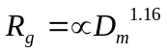 | equ. 11
The combination of the fractal law (equ. 1) and equ. 11 enables the expression of β as a function of N_{p}. This expression is finally constrained to respect β₀=√(5/3). The resulting expression of β is given in equ. 12. In the work of Chakrabarty et al., by measuring d_{f}=1.7, one can found α=0.50.
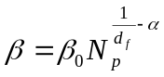 | equ. 12
Nevertheless, it has to be noted that α is suspected to change with the flow regime. For example the results by Wang and Sorensen (1999) in free molecular flow regime corresponds to α_{mol}=0.44+/-0.03. By using the multipole expansion technique, Kätzel et al. determined the aerodynamic force acting on aggregates in continuum flow regime as a function of the fractal dimension. Fortunately, their results are compatible with equ. 12 and corresponding α_{cont} parameter is done in equ. 13.
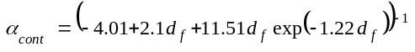 | equ. 13
In the present study, in order to be able to evaluate the mobility diameter of each aggregate as a function of its morphology, number of primary spheres and for any flow regimes (α_{mol} < α < α_{cont}), the Danheke approach is used. This method as also been used by Naumann, it consists in determining the mobility radius R_{m} that satisfies equ. 14 where β is determined by using equ. 12 with α = 0.44 for the estimation of β_{mol} in free molecular flow regime and with α given by equ. 13 for calculation of β_{cont}, in continuum flow regime.
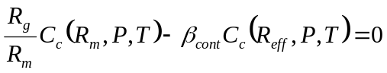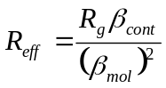 | equ. 14
Since after contact aggregation is taken into account, a new particle is selected following the method described hereafter.

Method for particles selection and residence time
As explained in introduction, if a “physical” residence time is wanted, particles can not be selected purely randomly. The reason is duration time 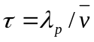 for a particle displacement along its mean free path is not the same for all particles. Noting that τ_{max} is the longest duration time for a particle to move along its mean free path, the ratio n_{s}(i)= τ_{max}/τ_{i} indicates the number of successive displacements done by the i^{st} aggregates along its mean free path during the elapsed time τ_{max}. In consequence, the i^{st} aggregates has to be selected n_{s} times more than particles with longest duration τ_{max}. So, at each new aggregation, the distribution of the duration time τ is calculated and is used to select particles statically in respect of the physical residence time progression. That statistical approach also permits to evaluate the total number of particles that must be called n_{t}=∑ n_{s}(i) for a residence time progression equal to τ_{max}. In consequence, when a particle is selected, the global residence time is incremented of τ_{max}/n_{t}.

Results
In the present paper, in order to illustrate the ability of the proposed algorithm to take into account some physical effects, some parameters have been varied: primary particle size, volume fraction, primary particle polydisersion in size. The classical analysis are reported and some new results are presented.
The detail of the parameters used for the calculations are reported in Tab 1.

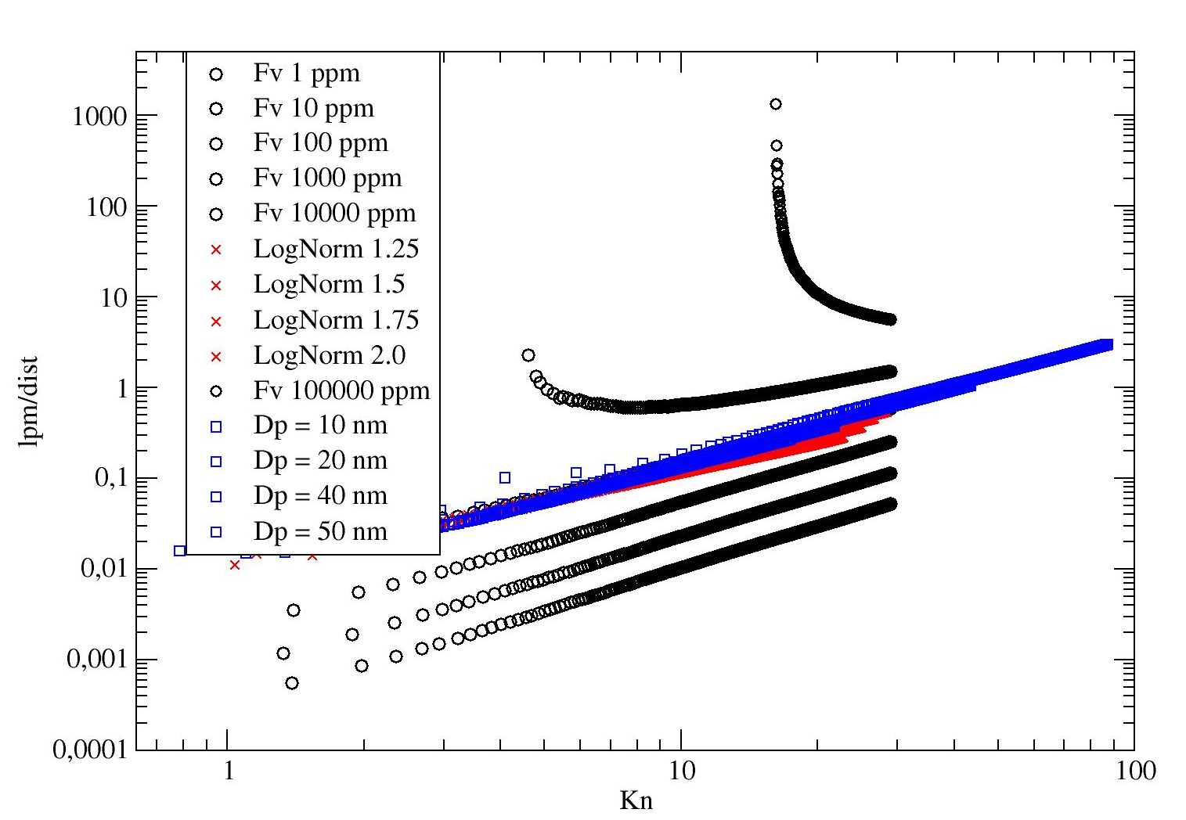
Figure 1 Illustration of the taking into account of the flow regime changing during aggregation and of a possible transition from Ballistic to Diffusion aggregation

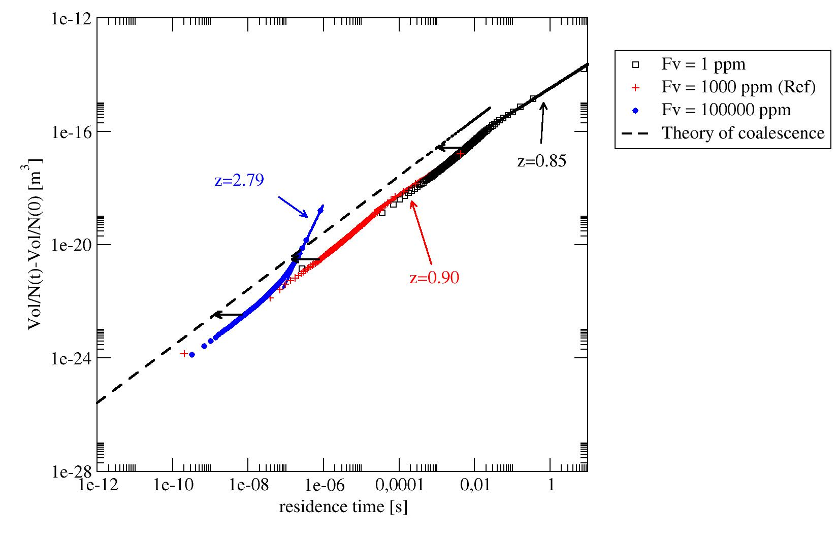
Figure 2 Residence time evaluation accuracy and kinetic of aggregation

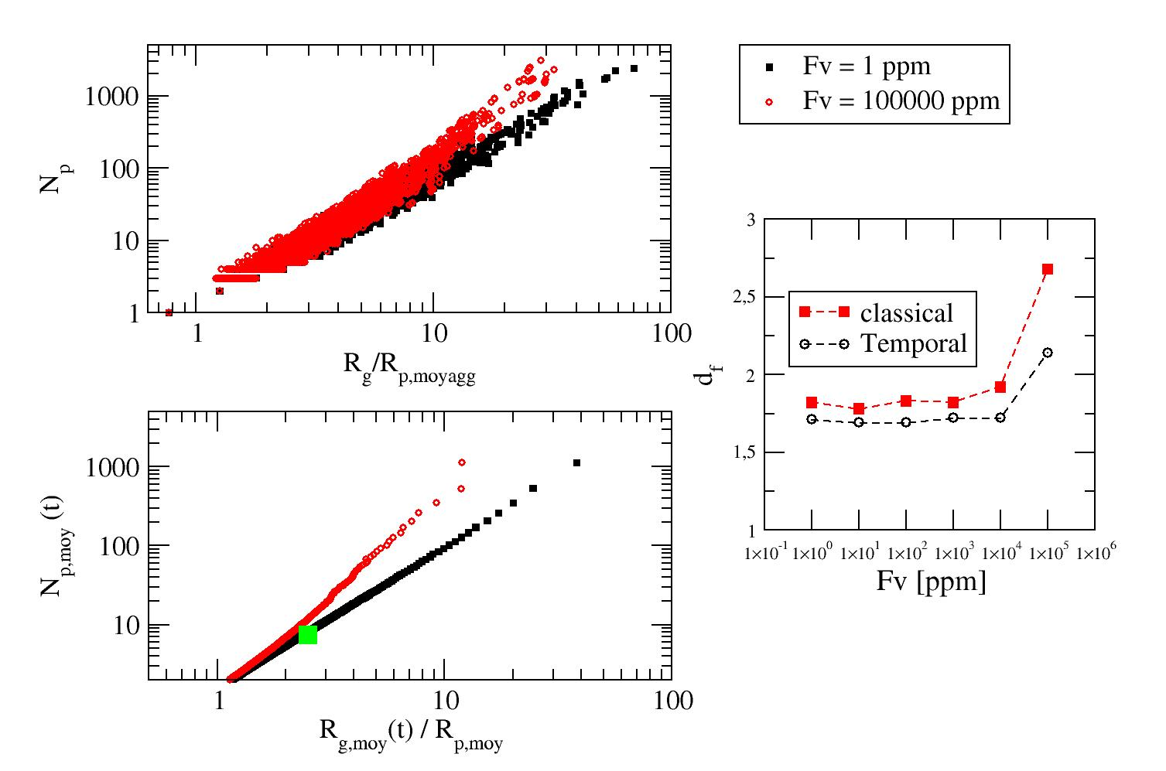
Figure 3 : Population based fratal law : classical and temporal approach

Figure 4, the main interest of the propo
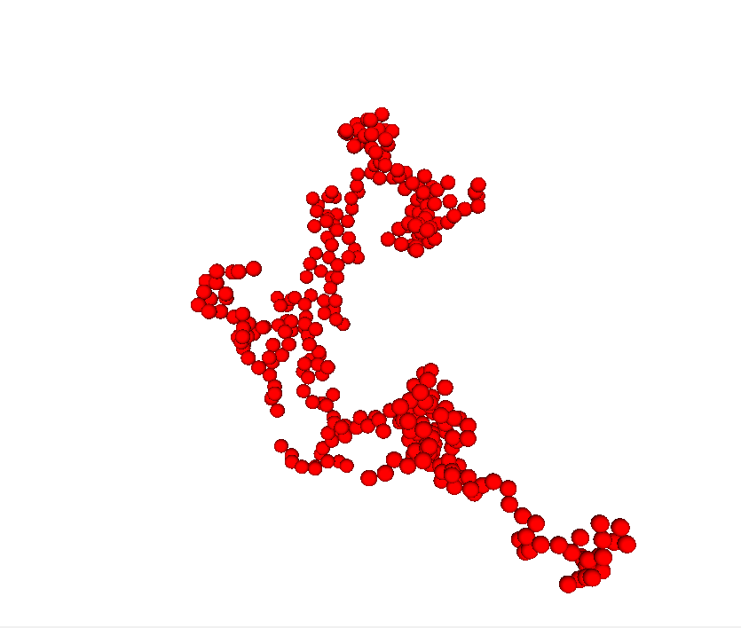 | 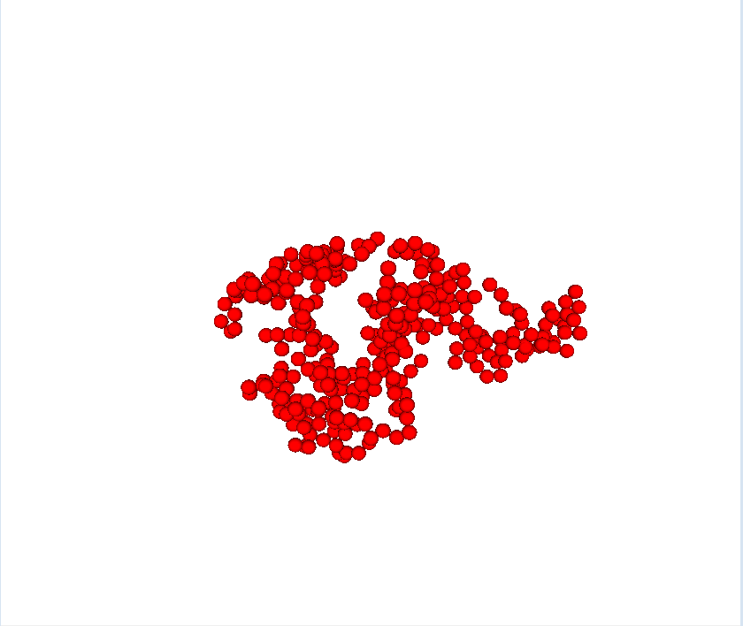 | 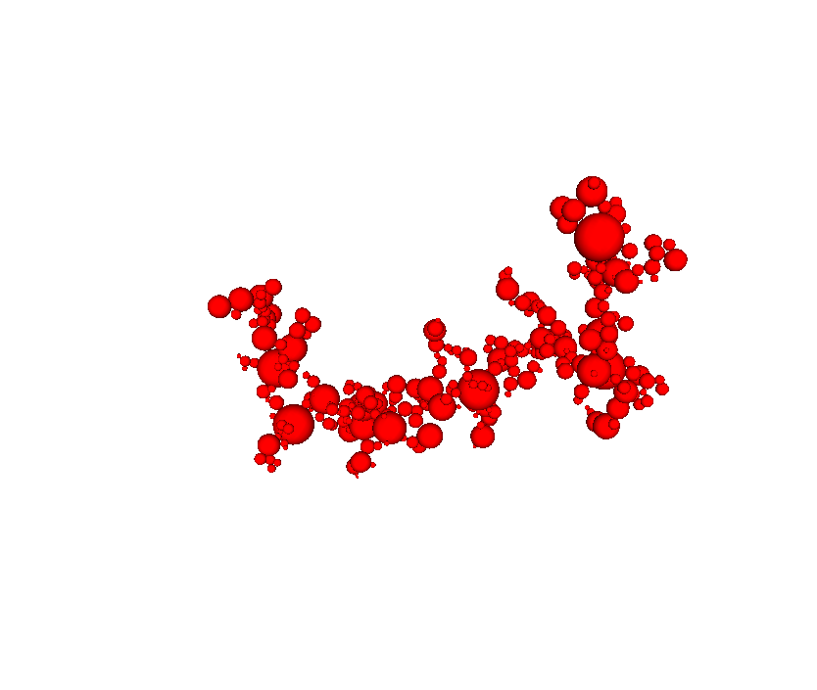
Low volume fraction  (1 ppm), Np=325 | High volume fraction  (100 ppk), Np=331 | High primary sphere polydispersity  (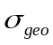=1.75), Np=338
Figure 4 Exemple of generated aggregates in different

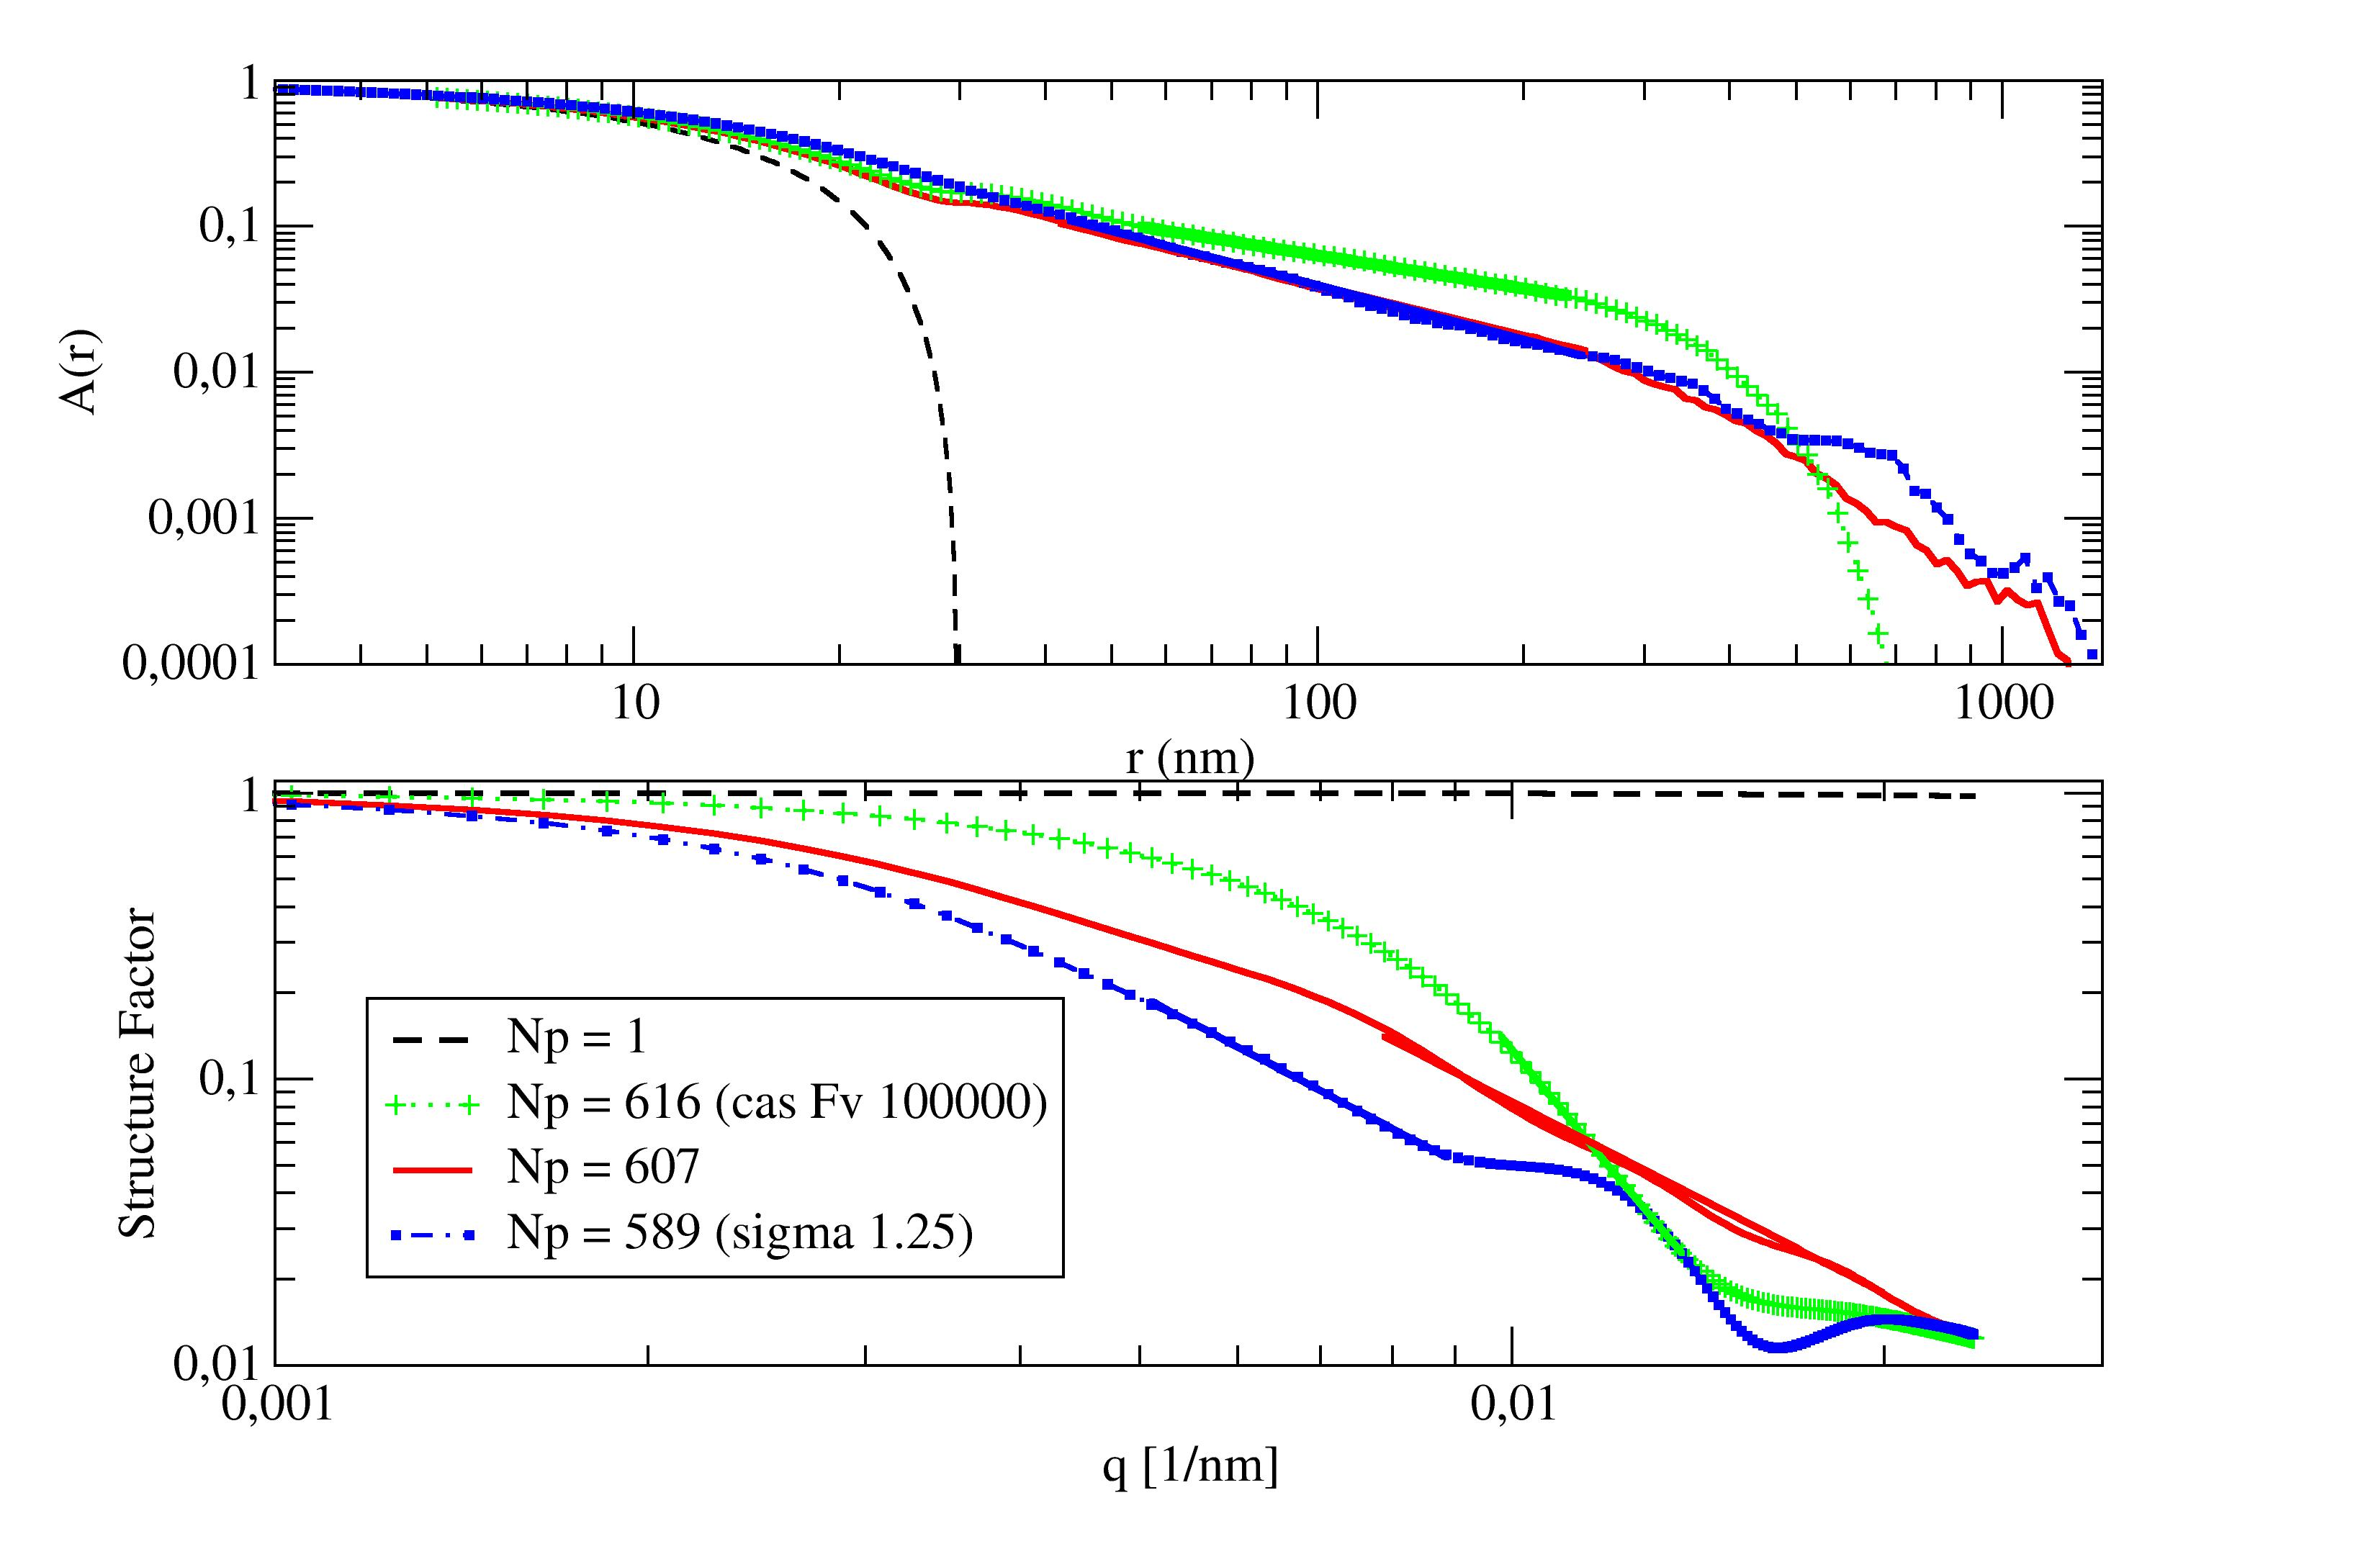
Figure 5 : structural fractal dimension of aggregates determined by pair-autocorrelation and structure factor extrapolation.

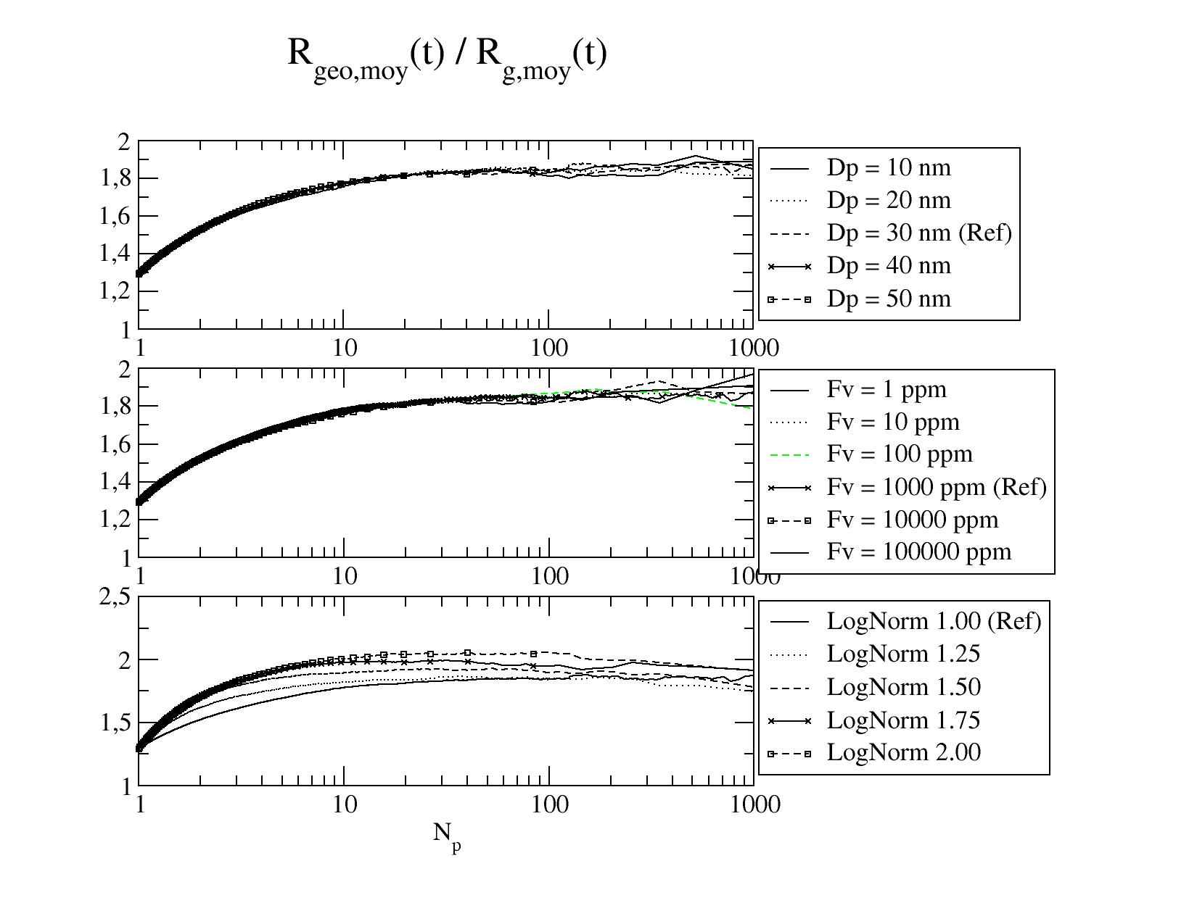
Figure 6 : Relation between radius of the surrounding sphere Rgeo and gyration radius and its dependency to the number of primary spheres.

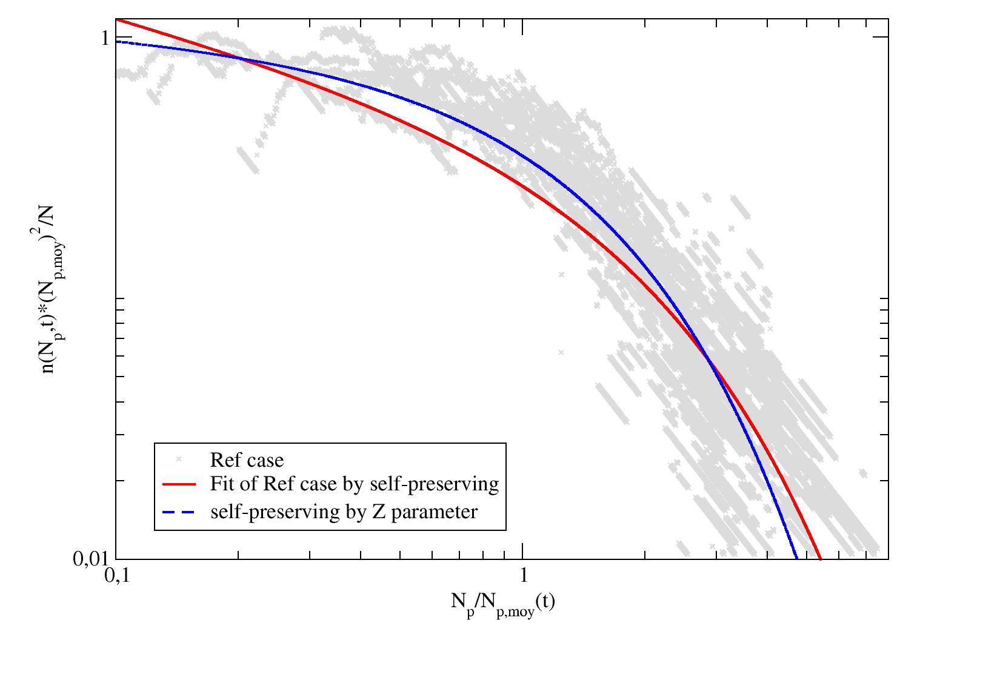
Figure 7 : Verification of the self-preserving size distribution for the reference case.

Aggregation kinetic and residence time

Aggregate morphology

Size distributions

Conclusion

